 |  | 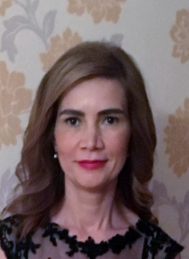
Europass
Curriculum Vitae
Personal information
First name(s) / Surname(s) |  | CĂLINA PALICIUC
Address(es) |  | 45, MILEA Street, Arad
Telephone(s) |  |  |  |  |  |  | Mobile: |  |  |  | 0745-116799
Fax(es)
E-mail |  | calinapaliciuc@yahoo.com
Nationality |  | Romanian
Date of birth |  | 20.06.1974
Gender |  | female
Desired employment / Occupational field |  | Assistant Professor, “AurelVlaicu” University
Work experience |  | 24 years
eeeeeeeeee
Dates |  | 2006-Present, Assistant Professor “AurelVlaicu” University, Arad
Occupation or position held |  | 2005- Ph. D in Philology
Main activities and responsibilities |  | 1999-2006-Teaching Assistant “AurelVlaicu” University, Arad
Name and address of employer |  | AurelVlaicu University
Dates |  | 1992-1997 –“West University”, Timisoara, Romanian-English Faculty
Title of qualification awarded |  | 1988-1992 – Economic High School, Arad
Principal subjects/occupational skills covered
Personal skills and competences |  | - Supervised undergraduate and graduate students in their final project preparation
Mother tongue(s) |  | Romanian
Other language(s)
Self-assessment |  |  | Understanding |  |  |  |  | Speaking |  |  |  |  | Writing
European level (*) |  |  | Listening |  | Reading |  |  | Spoken interaction |  | Spoken production
Language |  |  | C1 | English |  | C1 |  |  | C1 |  |  | C1 |  | C1
Language |  |  | A1 | Spanish |  | A2 |  |  | A1 |  |  | A1 |  | A1
 |  | (*) Common European Framework of Reference for Languages
Social skills and competences
Organisational skills and competences |  | - Participation at selecting the College Instructors  - Activities for Summer School
Technical skills and competences |  | MS Word, PowerPoint, Excel
Computer skills and competences
Other skills and competences  Social skills and competences |  | - The Ability to teach Academic English Lessons  - Philological Research  Communicative, sociable
Other skills and competences |  | Member of the professional associations:  Member of RSEAS(The Romanian Society for English and American Studies)  Member of ESSE (The European Society for the Study of English)

1.09.2022

