Lista lucrărilor științifice publicate

1. Mirela Sarbu, **Raluca Ica**, Alina Petrut, Željka Vukelić, Cristian V.A. Munteanu, Andrei J. Petrescu, Alina D. Zamfir, Gangliosidome of human anencephaly: a high resolution multistage mass spectrometry study, *Biochimie* **2019**,163, 142-151. **FI 3,41, AIS 1,179**
2. Mirela Sarbu, Liana Dehelean, Cristian V.A. Munteanu, **Raluca Ica**, Andrei J. Petrescu, Alina D. Zamfir, Human caudate nucleus exhibits a highly complex ganglioside pattern as revealed by high-resolution multistage Orbitrap MS, *J. Carbohydr. Chem.* **2019**, 38, 531-551. **FI 0,85, AIS 0,616**
3. **Raluca Ica**, Alina Petrut, Cristian V.A. Munteanu, Mirela Sarbu, Zeljka Vukelić, Ligia Petrica, Alina D. Zamfir, Orbitrap mass spectrometry for monitoring the ganglioside pattern in human cerebellum development and aging, *J. Mass Spectrom.* **2020**,55, e4502.doi:10.1002/jms.4502. **FI 1,98, AIS 1,044**

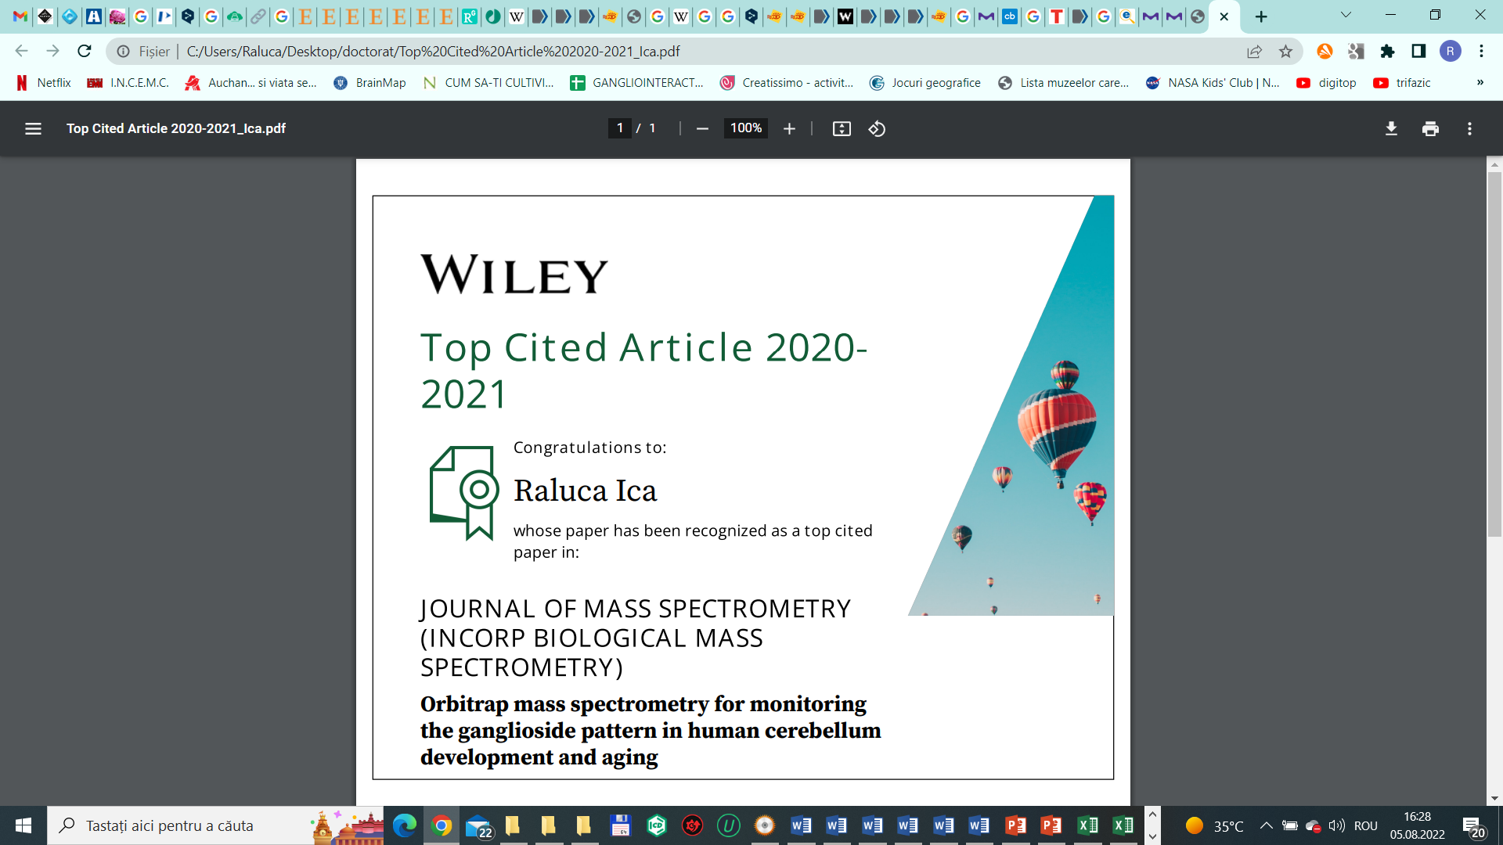

1. **Raluca Ica**, Anca Simulescu, Mirela Sarbu, Cristian V.A. Munteanu, Željka Vukelić, Alina D. Zamfir, High resolution mass spectrometry provides novel insights into the ganglioside pattern of brain cavernous hemangioma, *Anal. Biochem.* **2020**, 609. doi: 10.1016/j.ab.2020.113976. **FI 3,36, AIS 1,194**
2. **Raluca Ica**, Mirela Sarbu, Alina D. Zamfir, Developments and challenges in the application of separation and microfluidics methods coupled to mass spectrometry in glycomics of nervous system gangliosides, *Electrophoresis* **2021** Feb;42(4):429-449. doi: 10.1002/elps.202000236. **FI 3,59, AIS 0,910**
3. **Raluca Ica**, Cristian V.A. Munteanu , Željka Vukelić, Alina D. Zamfir, High resolution mass spectrometry reveals a complex ganglioside pattern and novel polysialylated structures associated to human motor cortex, *Eur J Mass Spectrom* (Chichester). **2021** Sep 13;14690667211040912. doi: 10.1177/14690667211040912. Online ahead of print. **FI 1,43, AIS 0,474**
4. Mirela Sarbu**\***, **Raluca Ica\***, Alina D Zamfir, Gangliosides as Biomarkers of Human Brain Diseases: Trends in Discovery and Characterization by High-Performance Mass Spectrometry, *Int J Mol Sci.* **2022** Jan 8;23(2):693. doi: 10.3390/ijms23020693. **FI 6,20, AIS 2,127 (*contributie egala)**
5. **Raluca Ica**, Kristina Mlinac-Jerkovic, Katarina Ilic, Tomislav Sajko, Cristian V.A. Munteanu, Alina D. Zamfir, Svjetlana Kalanj-Bognar, Gangliosidome of a Human Hippocampus in Temporal Lobe Epilepsy Resolved by High-Resolution Tandem Mass Spectrometry, *Molecules* **2022** Jun 23;27(13):4056. doi: 10.3390/molecules27134056. **FI 4,92, AIS 1,314**
6. Anca Suteanu-Simulescu, Alina Diana Zamfir, **Raluca Ica**, Mirela Sarbu, Cristian V A Munteanu, Florica Gadalean, Adrian Vlad, Flaviu Bob, Dragos Catalin Jianu, Ligia Petrica, High-Resolution Tandem Mass Spectrometry Identifies a Particular Ganglioside Pattern in Early Diabetic Kidney Disease of Type 2 Diabetes Mellitus Patients, *Molecules* **2022** Apr 21;27(9):2679. doi: 10.3390/molecules27092679. **FI 4,92, AIS 1,314**
7. Mirela Sarbu, **Raluca Ica**, Edie Sharon, David E. Clemmer, Alina D. Zamfir, Identification and Structural Characterization of Novel Chondroitin/Dermatan Sulfate Hexassacharide Domains in Human Decorin by Ion Mobility Tandem Mass Spectrometry, *Molecules* **2022**, 27 (18), 6026; https://doi.org/10.3390/molecules27186026. **FI 4,92, AIS 1,314**
8. Anca Suteanu-Simulescu, Mirela Sarbu, **Raluca Ica,**  Ligia Petrica, Alina D. Zamfir Ganglioside analysis in body fluids by liquid-phase separation techniques hyphenated to mass spectrometry, *Electrophoresis*, doi: 10.1002/elps.202200229. **2023, FI 2.9 AIS 0.9**
9. Mirela Sarbu, **Raluca Ica**, Edie Sharon, David E. Clemmer, Alina D. Zamfir Glycomics by ion mobility tandem mass spectrometry of chondroitin sulfate disaccharide domain in biglycan, *Journal Of Mass Spectrometry,*  doi: 10.1002/jms.4908.**2023, FI 2,39, AIS 0,88**
10. Maria-Roxana Biricioiu, Mirela Sarbu, **Raluca Ica**, ŽeljkaVukelić, Svjetlana Kalanj Bognar, Alina D. Zamfir Advances in mass spectrometry of gangliosides expressed in brain cancers, , *Int. J. Mol. Sci*. **2024**, <https://doi.org/10.3390/ijms25021335> **FI 3,20, AIS 1,61**
11. Maria-Roxana Biricioiu, Mirela Sarbu, **Raluca Ica,** ŽeljkaVukelić, David E. Clemmer, Alina D. Zamfir, Human Cerebellum Gangliosides: A Comprehensive Analysis by Ion Mobility Tandem Mass Spectrometry, *J Am Soc Mass Spectrom.* doi: 10.1021/jasms.3c00360, **2024, FI 3.1, AIS 0.76**
12. Biricioiu MR, Sarbu M, **Ica R**, Vukelić Ž, Clemmer DE, Zamfir AD. Advanced profiling and structural analysis of anencephaly gangliosides by ion mobility tandem mass spectrometry *Biochimie.* **2025** May;232:91-104. doi: 10.1016/j.biochi.2025.01.011. Epub 2025 Jan 28.
13. **Raluca Ica**, Mirela Sarbu, Roxana Biricioiu ,Dragana Fabris , Željka Vukelić andAlina D. Zamfir Novel Application of Ion Mobility Mass Spectrometry Reveals Complex Ganglioside Landscape in Diffuse Astrocytoma Peritumoral Regions *Int. J. Mol. Sci.* **2025**, *26*(17), 8433; [**https://doi.org/10.3390/ijms26178433**](https://doi.org/10.3390/ijms26178433) **FI 4,9**

**Capitole de Carte la Edituri Internationale**

1. Radu Albulescu, Andrei J. Petrescu, Mirela Sarbu, A.Grigore, **Raluca Ica**, Cristian V.A. Munteanu, A. Albulescu, Ioana Militaru, Alina D. Zamfir, Stefana Petrescu, C.Tanase, Mass spectrometry for cancer biomarker discovery, IntechOpen, **2019** DOI: 10.5772/intechopen.85609.
2. Alina D. Zamfir, **Raluca Ica**, Mirela Sarbu, Liquid-phase separation methods hyphenated to electrospray ionization mass spectrometry for structural analysis of chondroitin/dermatan sulfate, in ''Trends in Liquid-Phase Separation Techniques for Carbohydrate Analysis'', Editor Ziad El Rassi, Editura Elsevier, ISBN: 978-0-12-821447-3; pp. 529-562, **2021**; DOI: <https://doi.org/10.1016/C2019-0-01776-1>.

**Articole în reviste BDI**

1. **Ica R**, Sarbu M, Zamfir ADHigh resolution mass spectrometry with chip-based ionization for the assessment of noncovalent interactions of proteins with normal brain and brain tumor gangliosides*,* , *Scien. Tech. Bull-Chem. Food Sci. Eng.*Vol. 17 (XVIII), 2020, 15-19.

**FI 41,17**