Lista lucrărilor științifice publicate

- Mirela Sarbu, Raluca Ica, Alina Petrut, Željka Vukelić, Cristian V.A. Munteanu, Andrei J. Petrescu, Alina D. Zamfir, Gangliosidome of human anencephaly: a high resolution multistage mass spectrometry study, Biochimie 2019,163, 142-151. FI 3,41, AIS 1,179
- Mirela Sarbu, Liana Dehelean, Cristian V.A. Munteanu, Raluca Ica, Andrei J. Petrescu, Alina D. Zamfir, Human caudate nucleus exhibits a highly complex ganglioside pattern as revealed by high-resolution multistage Orbitrap MS, J. Carbohydr. Chem. 2019, 38, 531-551. FI 0,85, AIS 0,616
- Raluca Ica, Alina Petrut, Cristian V.A. Munteanu, Mirela Sarbu, Zeljka Vukelić, Ligia Petrica, Alina D. Zamfir, Orbitrap mass spectrometry for monitoring the ganglioside pattern in human cerebellum development and aging, J. Mass Spectrom. 2020, 55, e4502.doi:10.1002/jms.4502. FI 1,98, AIS 1,044
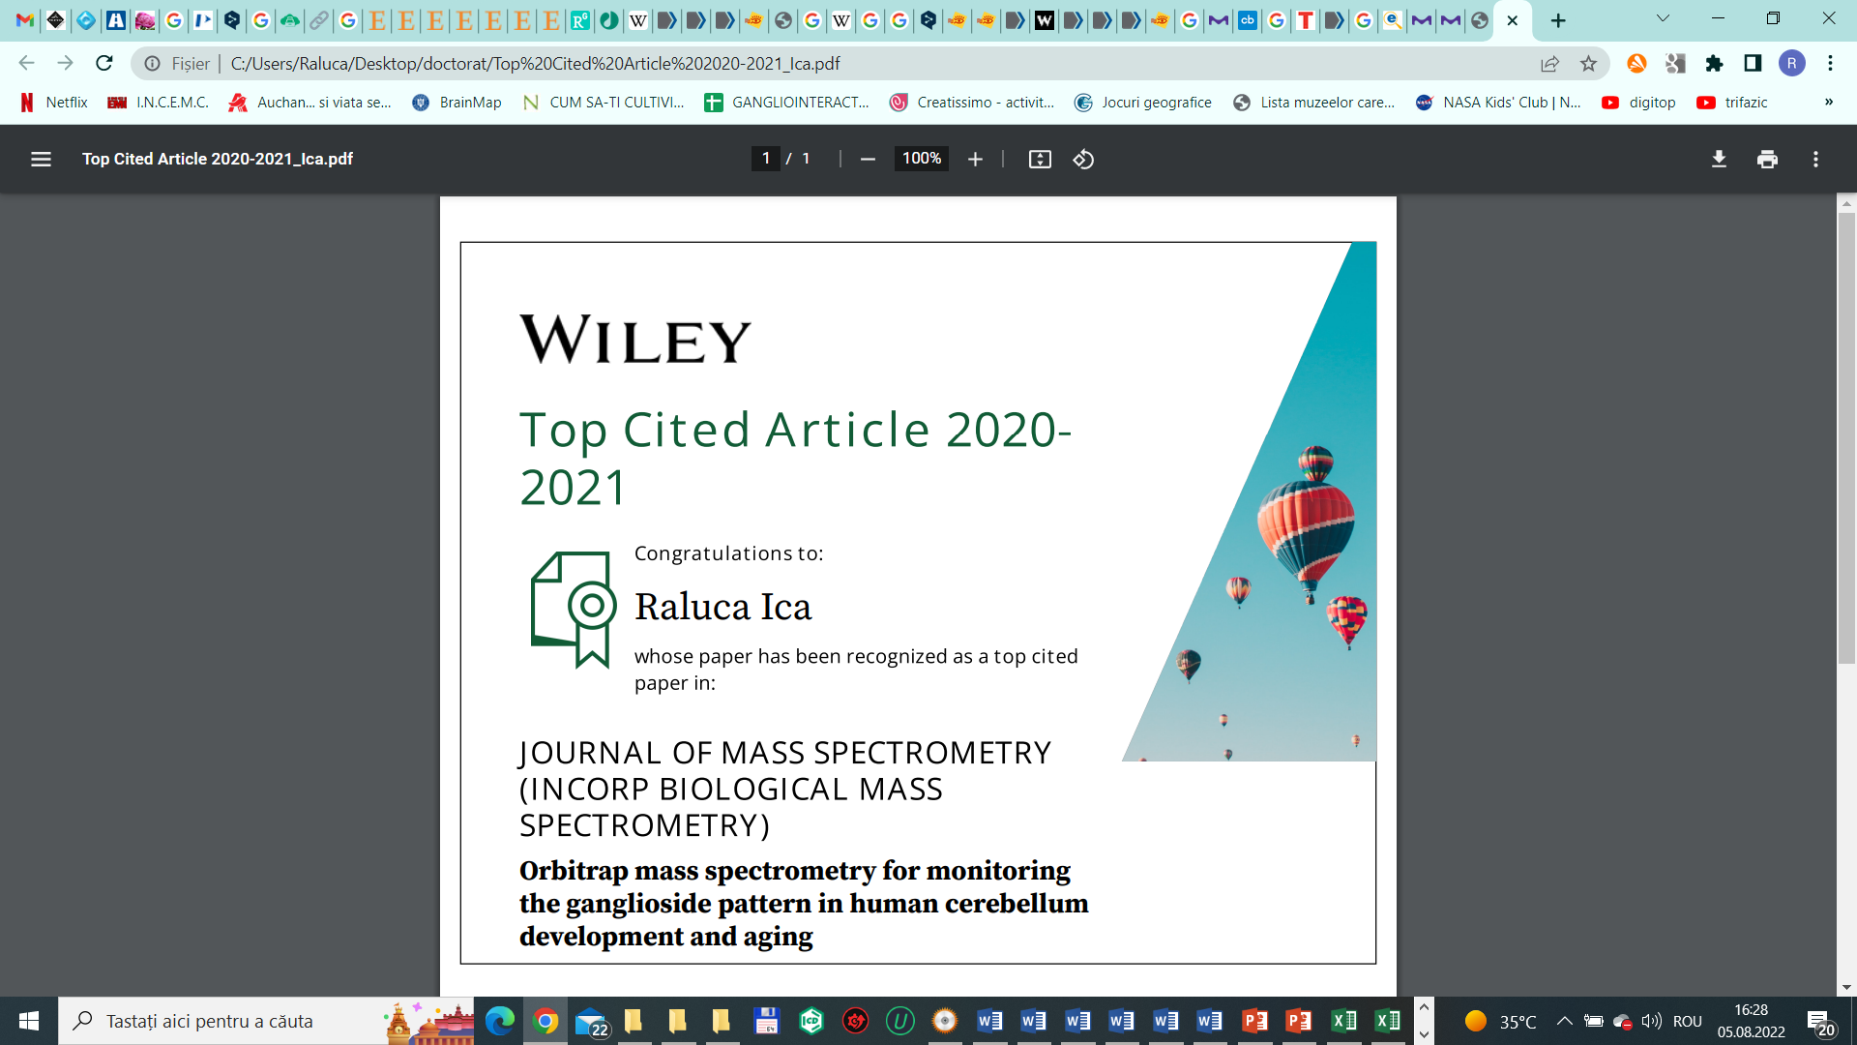
- Raluca Ica, Anca Simulescu, Mirela Sarbu, Cristian V.A. Munteanu, Željka Vukelić, Alina D. Zamfir, High resolution mass spectrometry provides novel insights into the ganglioside pattern of brain cavernous hemangioma, Anal. Biochem. 2020, 609. doi: 10.1016/j.ab.2020.113976. FI 3,36, AIS 1,194
- Raluca Ica, Mirela Sarbu, Alina D. Zamfir, Developments and challenges in the application of separation and microfluidics methods coupled to mass spectrometry in glycomics of nervous system gangliosides, Electrophoresis 2021 Feb;42(4):429-449. doi: 10.1002/elps.202000236. FI 3,59, AIS 0,910
- Raluca Ica, Cristian V.A. Munteanu , Željka Vukelić, Alina D. Zamfir, High resolution mass spectrometry reveals a complex ganglioside pattern and novel polysialylated structures associated to human motor cortex, Eur J Mass Spectrom (Chichester). 2021 Sep 13;14690667211040912. doi: 10.1177/14690667211040912. Online ahead of print. FI 1,43, AIS 0,474
- Mirela Sarbu*, Raluca Ica*, Alina D Zamfir, Gangliosides as Biomarkers of Human Brain Diseases: Trends in Discovery and Characterization by High-Performance Mass Spectrometry, Int J Mol Sci. 2022 Jan 8;23(2):693. doi: 10.3390/ijms23020693. FI 6,20, AIS 2,127 (*contributie egala)
- Raluca Ica, Kristina Mlinac-Jerkovic, Katarina Ilic, Tomislav Sajko, Cristian V.A. Munteanu, Alina D. Zamfir, Svjetlana Kalanj-Bognar, Gangliosidome of a Human Hippocampus in Temporal Lobe Epilepsy Resolved by High-Resolution Tandem Mass Spectrometry, Molecules 2022 Jun 23;27(13):4056. doi: 10.3390/molecules27134056. FI 4,92, AIS 1,314
- Anca Suteanu-Simulescu, Alina Diana Zamfir, Raluca Ica, Mirela Sarbu, Cristian V A Munteanu, Florica Gadalean, Adrian Vlad, Flaviu Bob, Dragos Catalin Jianu, Ligia Petrica, High-Resolution Tandem Mass Spectrometry Identifies a Particular Ganglioside Pattern in Early Diabetic Kidney Disease of Type 2 Diabetes Mellitus Patients, Molecules 2022 Apr 21;27(9):2679. doi: 10.3390/molecules27092679. FI 4,92, AIS 1,314
- Mirela Sarbu, Raluca Ica, Edie Sharon, David E. Clemmer, Alina D. Zamfir, Identification and Structural Characterization of Novel Chondroitin/Dermatan Sulfate Hexassacharide Domains in Human Decorin by Ion Mobility Tandem Mass Spectrometry, Molecules 2022, 27 (18), 6026; https://doi.org/10.3390/molecules27186026. FI 4,92, AIS 1,314
- Anca Suteanu-Simulescu, Mirela Sarbu, Raluca Ica, Ligia Petrica, Alina D. Zamfir Ganglioside analysis in body fluids by liquid-phase separation techniques hyphenated to mass spectrometry, Electrophoresis, doi: 10.1002/elps.202200229. 2023, FI 2.9 AIS 0.9
- Mirela Sarbu, Raluca Ica, Edie Sharon, David E. Clemmer, Alina D. Zamfir Glycomics by ion mobility tandem mass spectrometry of chondroitin sulfate disaccharide domain in biglycan, Journal Of Mass Spectrometry, doi: 10.1002/jms.4908. 2023, FI 2,39, AIS 0,88
- Maria-Roxana Biricioiu, Mirela Sarbu, Raluca Ica, ŽeljkaVukelić, Svjetlana Kalanj Bognar, Alina D. Zamfir Advances in mass spectrometry of gangliosides expressed in brain cancers, , Int. J. Mol. Sci. 2024, https://doi.org/10.3390/ijms25021335 FI 3,20, AIS 1,61
- Maria-Roxana Biricioiu, Mirela Sarbu, Raluca Ica, ŽeljkaVukelić, David E. Clemmer, Alina D. Zamfir, Human Cerebellum Gangliosides: A Comprehensive Analysis by Ion Mobility Tandem Mass Spectrometry, J Am Soc Mass Spectrom. doi: 10.1021/jasms.3c00360, 2024, FI 3.1, AIS 0.76
- Biricioiu MR, Sarbu M, Ica R, Vukelić Ž, Clemmer DE, Zamfir AD. Advanced profiling and structural analysis of anencephaly gangliosides by ion mobility tandem mass spectrometry Biochimie. 2025 May;232:91-104. doi: 10.1016/j.biochi.2025.01.011. Epub 2025 Jan 28.
- Ica R, Sarbu M, Biricioiu R, Fabris D, Vukelić Ž, Zamfir AD. Novel Application of Ion Mobility Mass Spectrometry Reveals Complex Ganglioside Landscape in Diffuse Astrocytoma Peritumoral Regions. Int J Mol Sci. 2025 Aug 29;26(17):8433. doi: 10.3390/ijms26178433. FI 4.9,
- Biricioiu MR, Mlinac-Jerković K, Ilic K, Sajko T, Ica R, Sarbu M, Clemmer DE, Kalanj-Bognar S, Zamfir AD. Advanced Ganglioside Characterization in Epileptic Human Hippocampus by Travelling Waves Ion Mobility Tandem Mass Spectrometry. J Mass Spectrom. 2025 Nov;60(11):e5190. doi: 10.1002/jms.5190. FI 2.0

Capitole de Carte la Edituri Internationale

- Radu Albulescu, Andrei J. Petrescu, Mirela Sarbu, A.Grigore, Raluca Ica, Cristian V.A. Munteanu, A. Albulescu, Ioana Militaru, Alina D. Zamfir, Stefana Petrescu, C.Tanase, Mass spectrometry for cancer biomarker discovery, IntechOpen, 2019 DOI: 10.5772/intechopen.85609.
- Alina D. Zamfir, Raluca Ica, Mirela Sarbu, Liquid-phase separation methods hyphenated to electrospray ionization mass spectrometry for structural analysis of chondroitin/dermatan sulfate, in ''Trends in Liquid-Phase Separation Techniques for Carbohydrate Analysis'', Editor Ziad El Rassi, Editura Elsevier, ISBN: 978-0-12-821447-3; pp. 529-562, 2021; DOI: https://doi.org/10.1016/C2019-0-01776-1.
Articole în reviste BDI
- Ica R, Sarbu M, Zamfir AD High resolution mass spectrometry with chip-based ionization for the assessment of noncovalent interactions of proteins with normal brain and brain tumor gangliosides, , Scien. Tech. Bull-Chem. Food Sci. Eng.Vol. 17 (XVIII), 2020, 15-19.
FI 41,17

